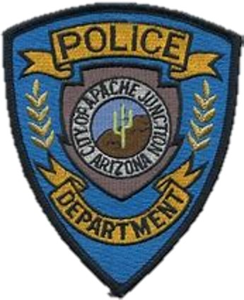 | Apache Junction Police Department  CEO: Chief Thomas E. Kelly  Accreditation Manager: Captain Arnold Freeman  Phone: 480-474-5461  Email: afreeman@ajcity.net  Entered Self-Assessment: 9-11-2018  Initial Accreditation Received:  Reaccreditation Received:
Clarkdale Police Department
CEO: Chief Randy S. Taylor
Accreditation Manager: Police Aide Jennifer Julian
Phone: 928-649-7700
Email: Jennifer.Julian@clarkdaleaz.gov
Entered Self-Assessment: 1-17-2019
Initial Accreditation Received:
Reaccreditation Received:
Florence Police Department
CEO: Chief Daniel Hughes
Accreditation Manager: Support Services Manager Deanna Husk
Phone: 520-868-7660
Email: Deanna.husk@florenceaz.gov
Entered Self-Assessment: 1-17-2019
Initial Accreditation Received:
Reaccreditation Received:
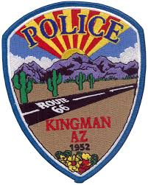 | Kingman Police Department  CEO: Chief Robert J. DeVries  Accreditation Manager: Deputy Chief Evan Kunert  Phone: 928-303-8126  Email: ekunert@cityofkingman.gov  Entered Self-Assessment: 9-11-2018  Initial Accreditation Received:  Reaccreditation Received:
Lake Havasu Police Department
CEO: Chief Dan Doyle
Accreditation Manager: Captain Troy Stirling
Phone: 928-680-5452
Email: stirlingt@lhcaz.gov
Entered Self-Assessment: 9-11-2018
Initial Accreditation Received:
Reaccreditation Received:
Marana Police Department
CEO: Chief Terry S. Rozema
Accreditation Manager: Deputy Chief Reuben Nunez
Phone: 520-382-2048
Email: rnunez@maranaaz.gov
Entered Self-Assessment: 9-11-2018
Initial Accreditation Received:
Reaccreditation Received:
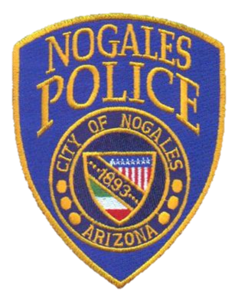 | Nogales Police Department  CEO: Chief Roy Bermudez  Accreditation Manager: Commander Carlos Jimenez  Phone: 520-287-9111  Email: cjimenez@nogalesaz.gov  Entered Self-Assessment: 9-11-2018  Initial Accreditation Received:  Reaccreditation Received:
Page Police Department
CEO: Chief Drew Sanders
Accreditation Manager: Lieutenant Larry Jones
Phone: 928-645-4378
Email: ljones@pageaz.gov
Entered Self-Assessment: 9-11-2018
Initial Accreditation Received:
Reaccreditation Received:
Paradise Valley Police Department
CEO: Chief Peter Wingert
Accreditation Manager: Lieutenant Freeman Carney
Phone: 480-948-7418
Email: fcarney@paradisevalleyaz.gov
Entered Self-Assessment: 4-11-2019
Initial Accreditation Received:
Reaccreditation Received:
Salt River Police Department
CEO: Chief Karl G. Auerbach
Accreditation Manager: Lieutenant Anthony Sandoval
Phone: 480-362-7966
Email: Anthony.Sandoval@SRPMIC-NSN.gov
Entered Self-Assessment: 9-11-2018
Initial Accreditation Received:
Reaccreditation Received:
San Luis Police Department
CEO: Chief Richard Jessup
Accreditation Manager: Lieutenant Miguel Alvarez
Phone: 928-281-7256
Email: malvarez@cityofsanluis.org
Entered Self-Assessment: 9-11-2018
Initial Accreditation Received:
Reaccreditation Received:
Snowflake-Taylor Police Department
CEO: Chief Larry D. Scarber
Accreditation Manager: Lieutenant Robert “Bobby” Martin
Phone: 928-536-7500
Email: rmartin@stpd.org
Entered Self-Assessment: 1-17-2019
Initial Accreditation Received:
Reaccreditation Received:
St. Johns Police Department
CEO: Chief Lance Spivey
Accreditation Manager: Detective Ty Bond
Phone: 928-337-2440
Email: tbond@stjohnsaz.gov
Entered Self-Assessment: 9-11-2018
Initial Accreditation Received:
Reaccreditation Received:
University of Arizona Police Department
CEO: Chief Brian A. Seastone
Accreditation Manager: Accreditation Manager Paula Dorer
Phone: 520-626-5660
Email: pdorer@email.arizona.edu
Entered Self-Assessment: 9-11-2018
Initial Accreditation Received:
Reaccreditation Received:
Wickenburg Police Department
CEO: Chief Les Brown
Accreditation Manager: Lieutenant Amy Sloane
Phone: 928-668-0504
Email: asloane@wickenburgaz.org
Entered Self-Assessment: 9-11-2018
Initial Accreditation Received:
Reaccreditation Received:
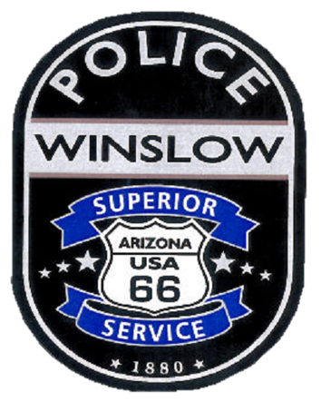 | Winslow Police Department  CEO: Chief Daniel J. Brown  Accreditation Manager: Lieutenant Ken Arend  Phone: 928-289-1432  Email: karend@winslowaz.gov  Entered Self-Assessment: 9-11-2018  Initial Accreditation Received:  Reaccreditation Received:

